Could 'Superdonors' Make Replacement Organs That Work In Anyone?
There’s a reason you can’t donate a kidney or bone marrow to just anybody. Each person’s immune system is tuned to reject things that look foreign.
But scientists have known for years there are people in the world with a rare gift—their cells look innocuous to the immune systems of many other people. What if they became “superdonors?” Could they donate some blood cells, which could then be coaxed through stem-cell reprogramming methods to make replacement cells for failing retinas, hearts, or neurons? Could those new human cells be consistently manufactured, and transplanted into millions of patients who suffer from macular degeneration, heart attacks, and Parkinson’s disease? Could it truly be done without the fear of the cells being rejected?
If so, might patients be able to avoid taking immune-suppressants the rest of their lives, which come with all kinds of drawbacks?
It’s a tantalizing vision which stem cell biologists have been discussing for years. Now a small biotech company, Madison, Wis.-based Cellular DynamicsInternational, is reporting today that it has obtained and begun manufacturing cells from two such “superdonors.” These two cell lines are believed to be genetically compatible with up to 19 percent of the U.S. population. The company says it has manufactured the two cell lines with a plan to hopefully develop them into simple, cost-effective replacement cell therapies. Over time, the company believes that it can build on the work on the original two cell lines, and get cells from 184 “superdonors,” which is what it would take to provide cells that could avoid immune rejection in 95 percent of the U.S. population.
“This is a great project and CDI CDI -0.17% [Cellular Dynamics] is in a good position to both contribute and to benefit,” said Sir Ian Wilmut, the professor at the University of Edinburgh best known for cloning Dolly the sheep. Wilmut, who has no financial ties to the company, has become familiar with the company’s work through his support for a global biobank from “superdonors” whose cell lines can avoid immune rejection when transplanted into others.
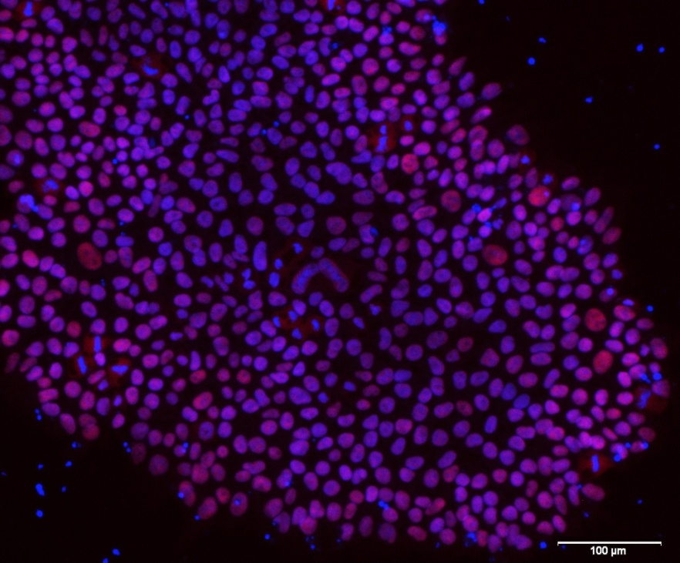
Induced Pluripotent Stem Cells (Image courtesy Cellular Dynamics)
Chuck Murry, a stem cell biologist at the University of Washington, said the idea of creating a central biobank of “superdonors” is one of the exciting applications of stem cell biology that is ripe for a company. The work hasn’t gotten past the talking stages, partly because scientists themselves usually aren’t funded or equipped to do it. “If I were a company and standing around watching people talk and not move, I’d be inclined to move because that’s what companies do,” Murry said.
Cellular Dynamics, the company co-founded by University of Wisconsin stem cell pioneer James Thomson, has become best known in recent years as a manufacturer of human cells for use in academic research and for pharmaceutical testing. That line of business throws off steady, solid cash flow. It has also established the company as a credible manufacturer of human cells with the kind of purity and consistency that the FDA requires of any company wishing to enter clinical trials, or to sell pharmaceuticals. Few academic labs are set up to meet those specifications. By honing its manufacturing skills first in the small-scale research market, Cellular Dynamics hopes to make the leap into the bigger potential market for manufacturing cell therapies.
Stem cells, for all their promise, haven’t led to the kinds of cell therapies that proponents touted in the 1990s. Various financial booms and busts have whipsawed the companies trying to build on the early promise. Cellular Dynamics, at this point, could be called one of the survivors. “We’re trying to ignite the field,” CEO Bob Palay said.
Besides the financial challenges, there are issues with transporting donor cells across international boundaries, and there is a touchy ethical aspect to the work. The blood from donors came through a third party clinic, which the company isn’t publicly identifying, Palay said. The individual donors gave informed consent to the clinic that their cells could be used for broad commercial purposes, including research and therapeutics, Palay said. Donors aren’t eligible to receive royalties on sales from cell therapy products that might be derived from their cells, and their names are being kept anonymous to Cellular Dynamics, he said.
The people who donated blood have rare genetic profiles in their human leukocyte antigens (HLA), which makes them broadly compatible with as much as 19 percent of the U.S. population. Other such “HLA-superdonors” have been identified in various biobanks, but the first two donors appear to be the ones compatible with the largest percentages of the U.S. population, based on calculations performed by the company, Palay said. Partly because of the genetics of HLA matching, it is typically more difficult to find superdonors for patients of African descent, he said. That raises social justice questions, in terms of which groups stand to benefit first, Murry said.
The first potential applications for replacement cell therapies are with retinal pigment epithelial (RPE) cells. Last October, the company received a $1.2 million contract from the National Eye Institute to take its induced pluripotent stem cells and turn them into human retinal cells that are good enough to be used in clinical trials. That is one area ripe for research because the clinical need for patients with macular degeneration is large, the delivery of cells to the back of the eye is easier than in some other organs, and researchers can clearly observe whether the implanted cells are doing what they are supposed to do.
Cellular Dynamics also has hopes to use its superdonor-derived cells to make replacement heart cells (cardiomyocytes), which could be injected to regenerate some of the damaged heart tissue left over in people who’ve had heart attacks. Another idea is to make dopamine-secreting neurons which could be implanted in patients with Parkinson’s disease.
All the work is still a long way from large-scale, real-world use. Significant testing in animals will be required before Cellular Dynamics can take one of its cell therapies into clinical trials. The company will have to decide which programs to advance first, and whether to push into the clinic alone, or with help from partners. The National Eye Institute has said it hopes to bring the replacement eye cells into a clinical trial in 2017.
For more detail on the “superdonor” biobanking project from Sir Ian Wilmut, see the my new subscription publication–Timmerman Report.

